
Birding Trip Report

Patagonia
November 9th to 30th

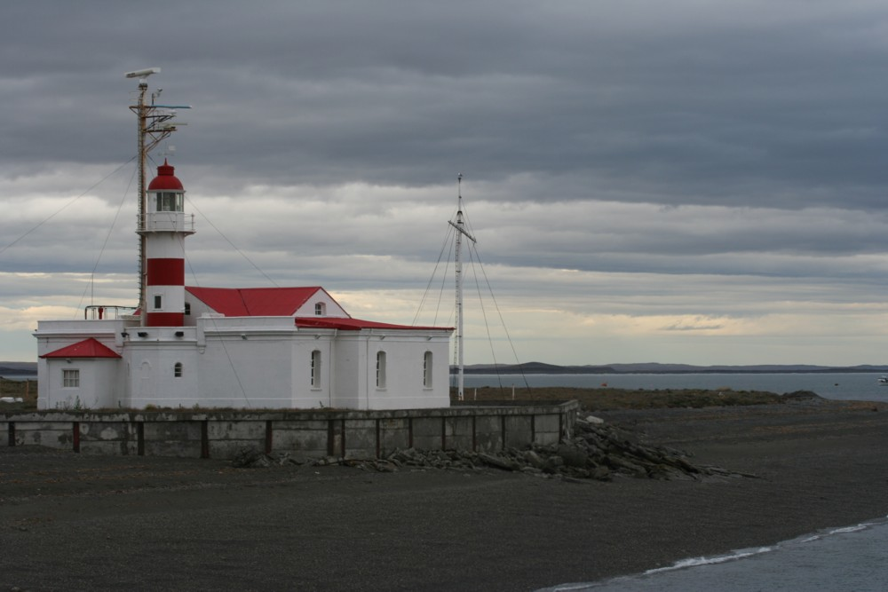

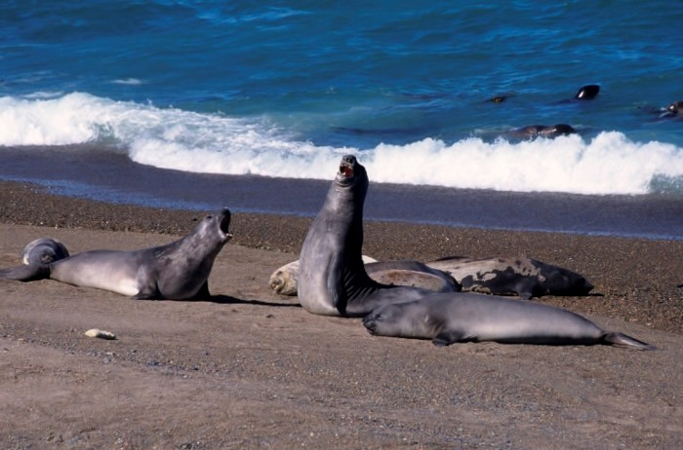
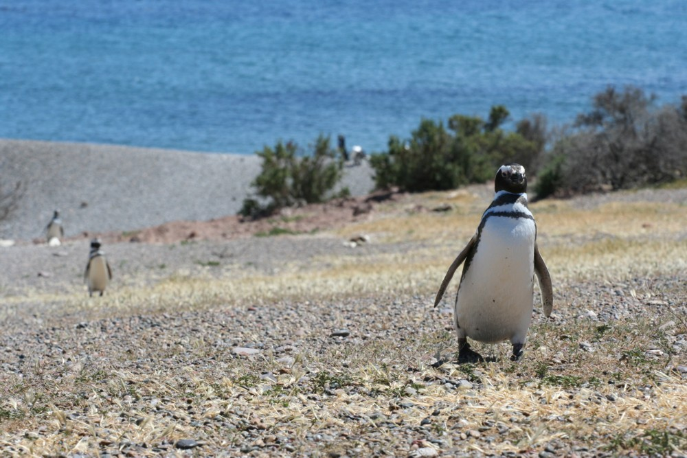

Leader, trip redaction : Fabrice Schmitt
Participants : Skyp and Lyn Nelson, Jay Lamb
Driver : Julio Benites
Kolibri Expeditions www.kolibriexpeditions.com

While guiding a Kolibri Expeditions 'Central Peru Trip' I had one of most incredible experiences of my life getting to guide for the world famous Skip Nelson and his beautiful wife Lyn in October of 2005.

Skip and Lyn decided to come back to South America in 2006/07for a 6 month trip which included Ecuador, Peru, Bolivia, Argentina and Chile. As I'm living in Chile and am well acquainted with the birds of Argentina and Chile, they kindly asked me if I would like to guide them for the Chile-Argentina part of their trip... of course, I immediately accepted !!

Let's go for a 70 day trip via the northern Chilean desert, Argentinean altiplano, pampas, tropical forest, sea shores, Patagonian scrubs, glaciers, Chilean fjords, etc...
Seventy days full of birds, birds, and birds, but also incredible mammals and landscapes !
Seventy days of great wine, wonderful barbecue, seafood, even lemon liquor with Hoy's Screech-owl singing in the garden of the hotel, ... and of course, peanut butter !! (I guess Skip could not survive 2 weeks without peanut butter, and after this trip, I'm almost addicted…)
Seventy days during which Skip and Lyn where obliged to enjoy my French accent...

This trip report only represents one part of the whole trip : "Patagonia, November 9th to 30th"

Many of the Chilean species were also seen during the North-west Argentina and Patagonian portion of the complete trip.
If you want to have a complete look at our 70 day trip, please read :

- "North-West of Argentina, October 13th to 29th"
- "Few days in the North-east of Argentina, October 31st to November 6th"
- "Central and Northern Chile, with Juan Fernandez island, October 8th to 12th and December 4th to 17th"

If you are interested in a trip in Chile, Argentina or Peru, contact kolibriexp@gmail.com

Itinerary

Lyn didn't participate to the "North-West of Argentina" part of the trip. She flew back to United States for one week, while Skip and Fabrice were birding this area (see trip report).
For the Patagonian and the Central Chile part of the trip, a third birder joined the team, Jay Lamb. He arrived in Buenos Aires the November 8th, and knew the Nelsons before the trip as he already did several birding trip with them.

November 9th
Lyn is flying back from the United States this morning, and Skyp looked for her at the airport. She was tired after a night in the plane, and so the Nelsons didn't bird that day.
With Jay, we took our breakfast in the Otamendi park, where we had good views on the 2 Reedhaunter species, and then we prospected the Perdices area.... we were not disappointed as we found a pair of Saffron-cowled Blackbird, 1 Dark-throated Seedeater, and lot's of more lifers for Jay !
Night in Buenos Aires.

November 10th
We bird the Costanera Sur Reserve in the morning, where we saw good numbers of waterbirds, even if the water level was very low.
Then we drove to San Clemente del Tuyu, with few stops on the way, and a visit to the Punta Rasa area in the evening where we found few singers of Bay-capped Wren-spinetail.
Night in San Clemente del Tuyu.

November 11th
We spent the whole day around San Clemente.
In Punta Rasa we found a group of Olrog's Gull, and several others species of terns and shorebirds.
An other speciality of the area, the Hudson's Canastero, will be found easily around Campo del Tuyu.
Night in San Clemente del Tuyu.

November 12th
A driving day to reach Bahia Blanca.
On the way, Jay will see two lifers that Skyp and Lyn already had in the north of Argentina : the Spotted Nothura and the Burrowing Parrot.

November 13th
We spend all the morning around Bahia Blanca, with Cristobald, a local birder. With his help, we easily found our main target, the Pampas Meadowlark, between the numerous Long-tailed Meadowlark.
We also spent few hours on the Cristobald property, in search of the Yellow Cardinal and others Chaco specialities.
Driving all the afternoon, and night in Viedma.

November 14th
Birding around Las Grutas in the morning, where we found our 4 main targets : Hudson's Black-tyrant, Grey-crowned Tyrannulet, Black-crowned Monjita and Carbonated Sierra-finch. The Cinnamon Warbling-finch was very common there (we worked so hard to find it in the NW of Argentina...) but we dipped on the Yellow Cardinal (sad for Lyn and Jay who were not with us when we found a beautiful male in the NE of Argentina...).
After this excellent birding morning, we drove to the Valdes Penisula.
Camping in Puerto Pyramides.

November 15-16th
We spent almost two full days on the Valdes Peninsula.
The good birds we found here include Patagonian Canastero, Rusty-backed Monjita, Elegant-crested Tinamou, Tawny-throated Dotterel and even a Hall's Giant-petrel.
But this peninsula is also a wonderful place for mammals watching, and we saw Elephant Seal, Southern Right Whale, Khiller Whale, Mara, Hairy Armadillo, etc..
The 16th, on our way to Trelew, we stopped at the Sea Lions colony of Punta Loma but we didn't see the expected Snowy Sheathbill there.
Night in Gaiman.

November 17th
Bad news this morning, Lyn was sick and felt very bad.
We followed our way to the south doing one main stop at Punta Tombo, the biggest continental Magellanic Penguins colony. We also found there 1 Band-tailed Earthcreeper, few Brown Skua and 4 pairs of Chubut Steamer-duck.
Night in Comodoro Rivadavia.

November 18th
Lyn didn't feel better. We went to a clinic where a doctor diagnostic the infection and give her medications.
A loooong drive today to Gobernadores Gregores.
At Comodoro Rivadavia, we found 52 Snowy Sheathbill on the shore and our first Dolphin Gulls. But the bird of the day is definitely this Patagonian Tinamou who crossed the road few kilometres before Gobernadores !
Night in Gobernadores Gregores.

November 19th
Lyn stayed all day at Gobernadores Gregores.
A complete day birding the extremely windy Patagonian steppes. We spent the morning on the Stroebel plateau where we saw (only) 1 Hooded Grebe and 1 more Patagonian Tinamou. Others nice species where Magellanic plover and Flying Steamer-duck.
In the afternoon, we bird around the Estancia Angostura and we easily found 2 Austral Rail !!
Few birds today, but what birds !!!
Night in Gobernadores Gregores.

November 20th
Lyn felt a little bit better, enough to try a look on the Austral Rail.
The rail played the game and quickly came in the open, at only few meters from us !
Another long drive today on the unpaved austral road (the famous road 40).
Night in El Calafate.

November 21th
Morning in the scenic Perito Moreno NP. The view on the glacier is impressive !!
On the way to the glacier, we found a family of Spectacled Duck, and Skyp saw the first Austral Parakeet.
In the forest, a Magellanic Tapaculo was singing and rapidly came in the open after few playback. We also had good views on Fire-eyed Diucon, Thorn-tailed Rayadito and Patagonian Sierra-finch.
Drive in the afternoon to the Chilean border.
Night in Cerro Castillo.

November 22th
Lyn was better but still sick, and it was better to avoid camping in the Torres del Paine NP.
As we already saw all the targets of the area, the group decided to don't go in the NP and follow our way to Punta Arenas.
In the late evening, we did bird the south of Punta Arenas where we saw 4 species of geese including a group of at least 30 Ruddy-headed Geese !
Night in Punta Arenas.

November 23th
We crossed the Strait of Magellan this morning !! Jay, retired from the US Navy, was dreaming about that since years !!
We need 2h30 to reach Porvenir in Tierra del Fuego, and the pelagic was good : several Black-browed Albatros, Southern Giant-petrel, 8 Southern Fulmar, +30 Magellanic Diving-petrel... we even saw a Sey Whale and a group of Dusky Dolphin !!
Night in Rio Grande (Argentina)

November 24th
Wind, cold and rain... this is the spring in Tierra del Fuego !!
Even if we thought we were still in winter, the birds will quickly show us that we were in spring : chicks everywhere !
Around Rio Grande, we found chicks (and the alarming corresponding adult pair) of Tawny-throated Dotterel, Least Seedsnipe and Two-banded Plover.
On our way to Ushuaia, we stopped at the Garibaldi pass for a short trek in search of the White-bellied Seedsnipe. Unfortunately, it was raining (sometimes snowing) and there was no marked trail... we had to do our own trail in the muddy forest... short trek but difficult...
In the alpine habitat we easily found 2 pairs of Yellow-bridled Finch, and a pair of White-throated Caracara flew over our head... but from White-bellied Seedsnipe we only found droppings...
Night in Ushuaia.

November 25th
Whole day in the Tierra del Fuego NP.
The park is scenic and the birds living there are sought after targets !!
It rained almost all the morning, but when the rain stopped, the birds where very active in the forest and we easily found the White-throated Treerunner, a wonderful furnarid close to a Nuthatch.
A little bit latter, we found 4 Magellanic Woodpecker, 2 males and 2 females together, who gave us a nice show during at least 20 minutes.
On the shore of the Beagle channel, we found our first Flightless Steamer-duck, and few Kelp Goose.
And we also had a close view on a Magellanic Horned-owl incubating... on the same nest than 4 years ago !
Camping in the Tierra del Fuego NP.

November 26th
The trek of the trip !
Following the indication of a park ranger, we began a scenic, but also long and difficult trek in the hope to find the White-bellied Seedsnipe. The trail began close to the old rubbish dam of Ushuaïa, and was crossing the pristine Nothofagus forest, to reach the alpine habitat where we looked for the seedsnipe.
Unfortunatly, we only found a pair of Yellow-bridled Finch, but no Seedsnipe !....
Anyway, the trek was wonderful and will be an unforgettable memory !

November 27th
We spent the morning around the Martial glacier.
The weather was bad this morning but fortunately, Lyn found a pair of White-bellied Seedsnipe just before it began to snow !!
After a wonderful view of this difficult species, and 30 minutes walking with rain and snow, we found a nice place with hot wine.... a new species and a nice drink, life is nice !
In the afternoon we took the boat to sail on the Beagle channel and to visit the Estancia Haberton. There, the boat stop close to a big Magellanic Penguin colony, where few pairs of Gentoo Penguin are also breeding. A second lifer... life is very nice !

November 28th
A mostly driving day, from Ushuaïa to Rio Gallegos.
On the way, we stopped to have nice view on a pair of Austral Canastero.
Night in Rio Gallegos.

November 29th
We didn't have lot's of species left, but one of them was the Canary-winged Finch. We found it on the way to Cabo Virgines.
Once the bird seen, we drove to Punta Arenas where we spent the night.

November 30th
Jay and Fabrice did bird the south of Punta Arenas in the morning. No new species but good view on Ruddy-headed Goose and Spectacled Duck.
Unfortunately, in the beginning of the afternoon we brook an axe of the minibus............
Meanwhile Julio was trying to repair the minibus, all the team went to Puerto Natales by bus. From there, Skip, Lyn and Jay began their Navimag cruise to Puerto Montt, sailing between the Patagonian channels.
All the team will meet again in Puerto Montt the December 4th for the beginning of the central Chile trip (see the "North and Central Chile, including Juan Fernandez" trip report).

Some pictures

All pictures from Fabrice Schmitt, and done during this trip.

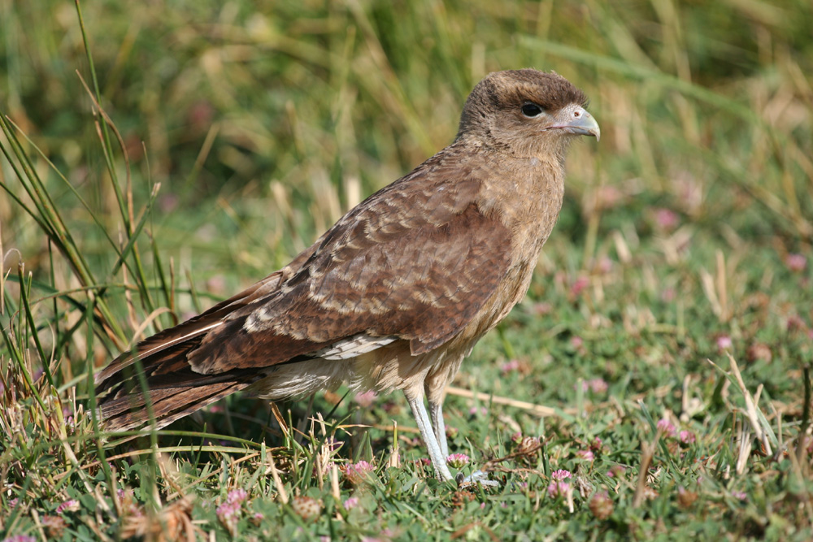
Chimango Caracara
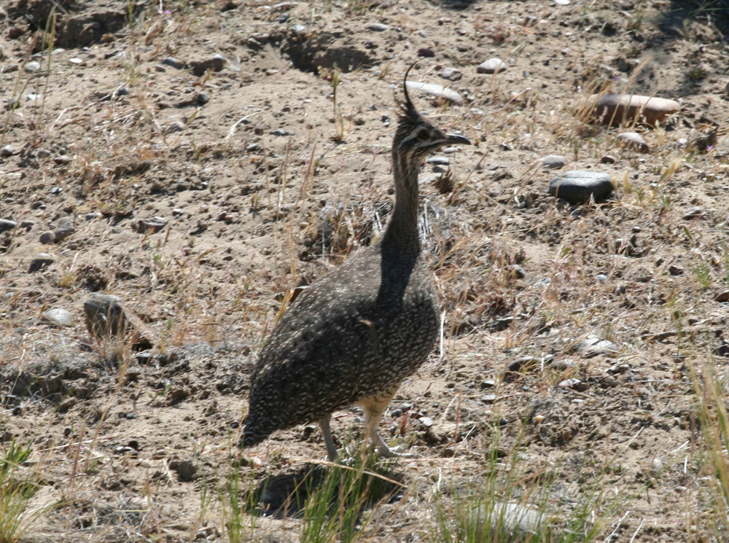
Elegant Crested Tinamou
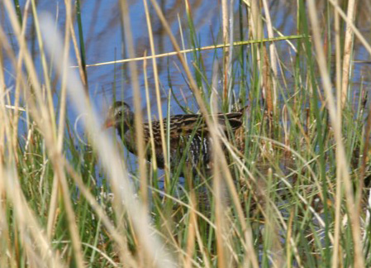
Austral Rail
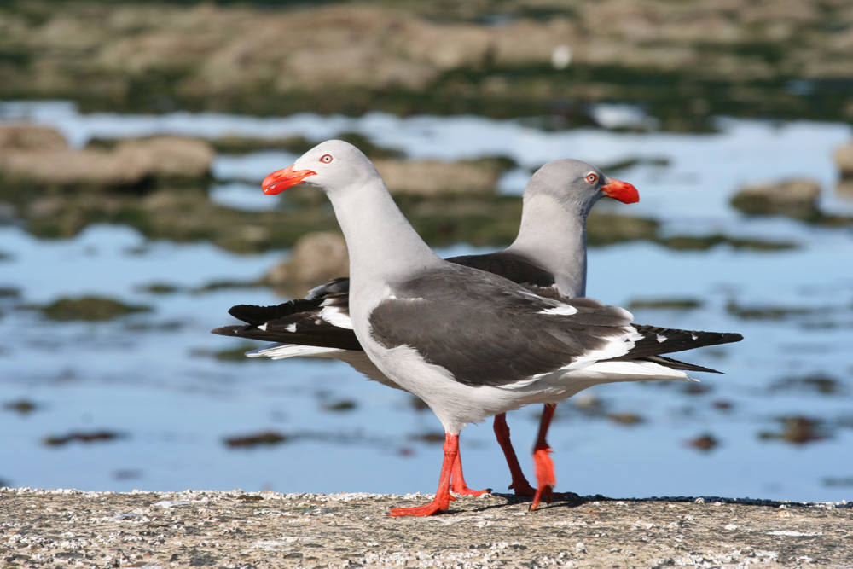
Dolphin Gull
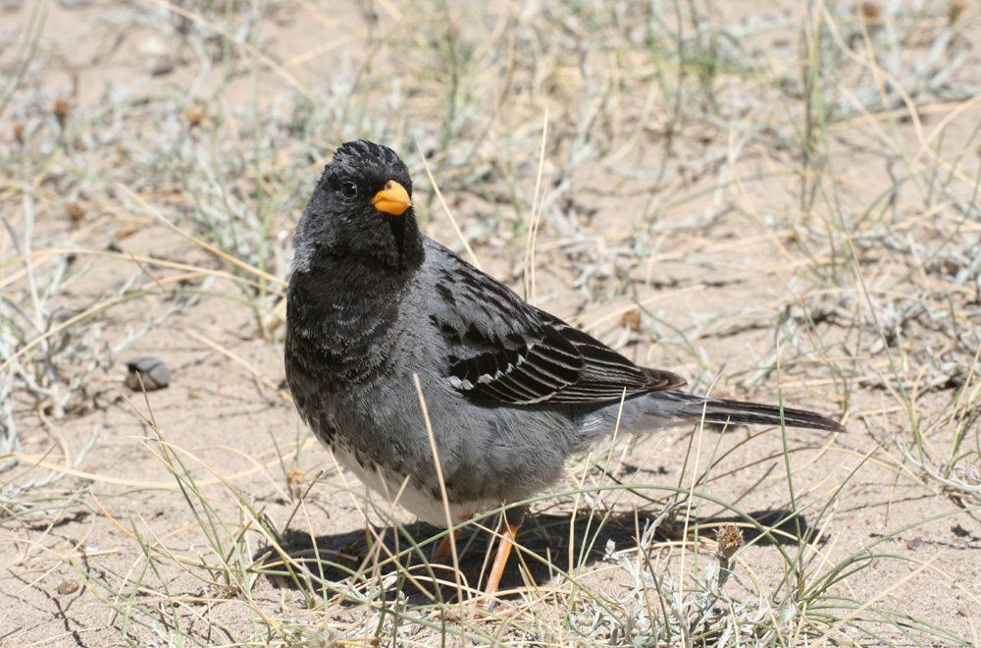
Mourning Sierra-finch
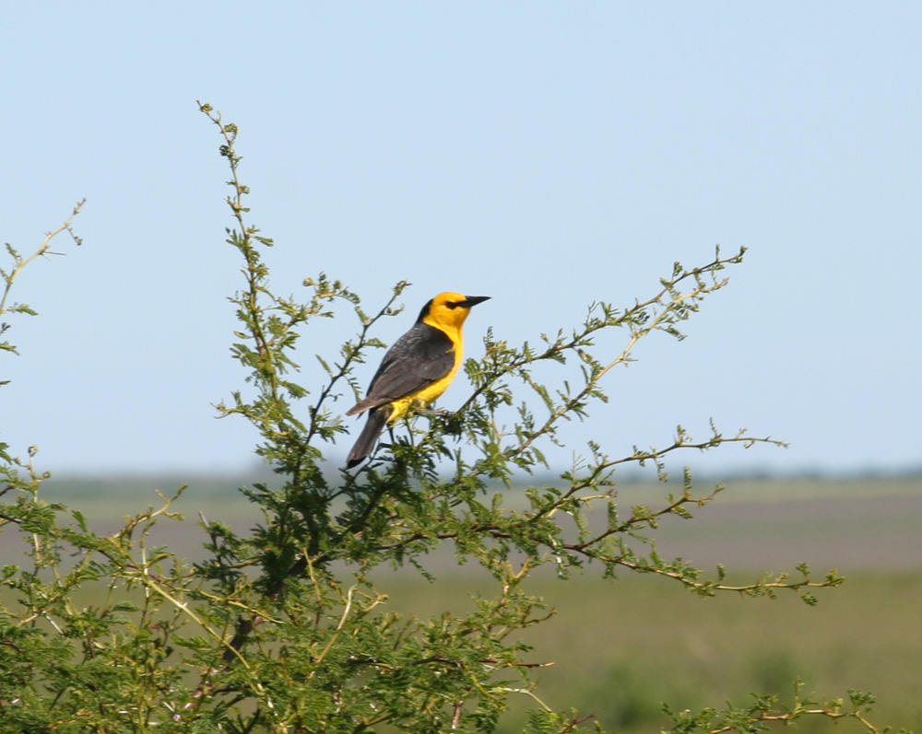
Saffron-cowled Blackbird
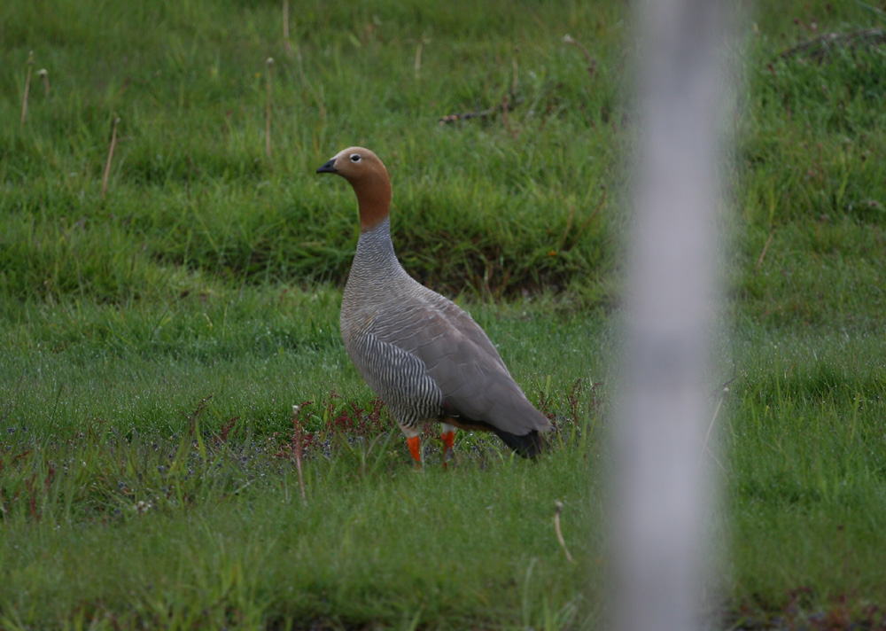
Ruddy-headed Goose
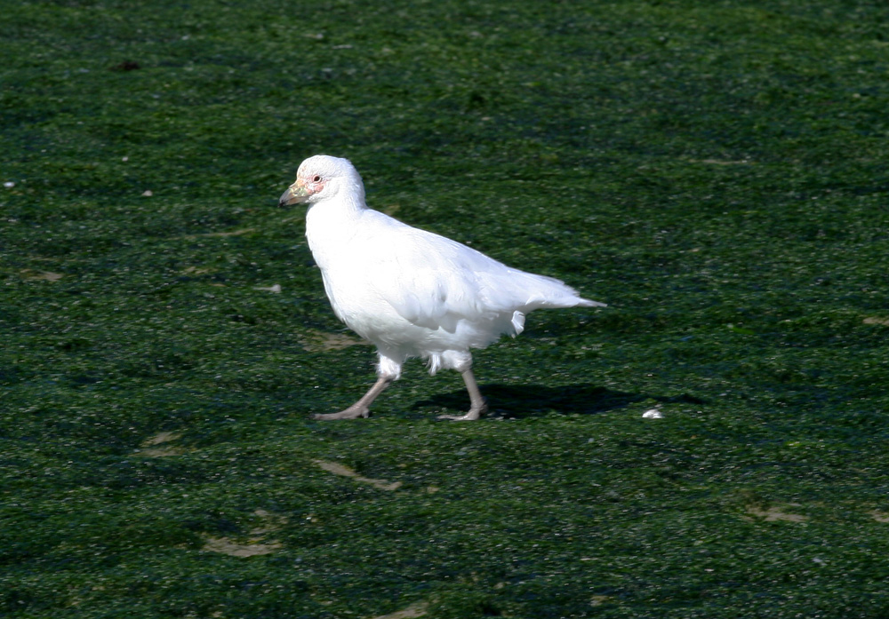
Snowy Sheathbill
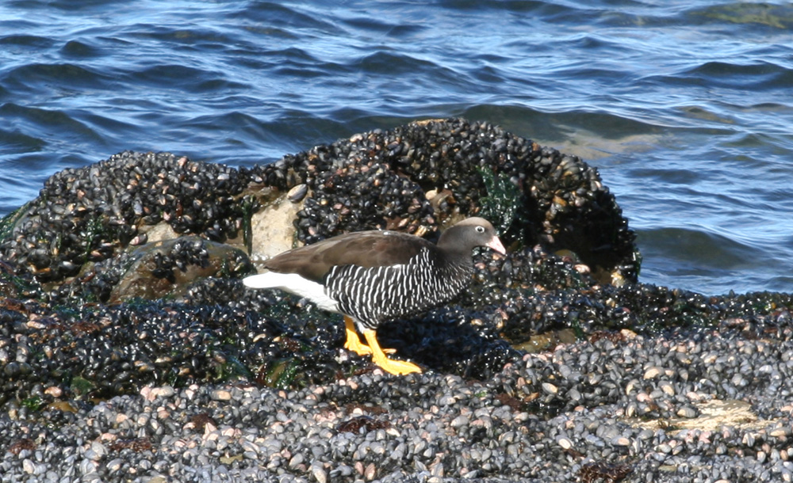
Kelp Goose
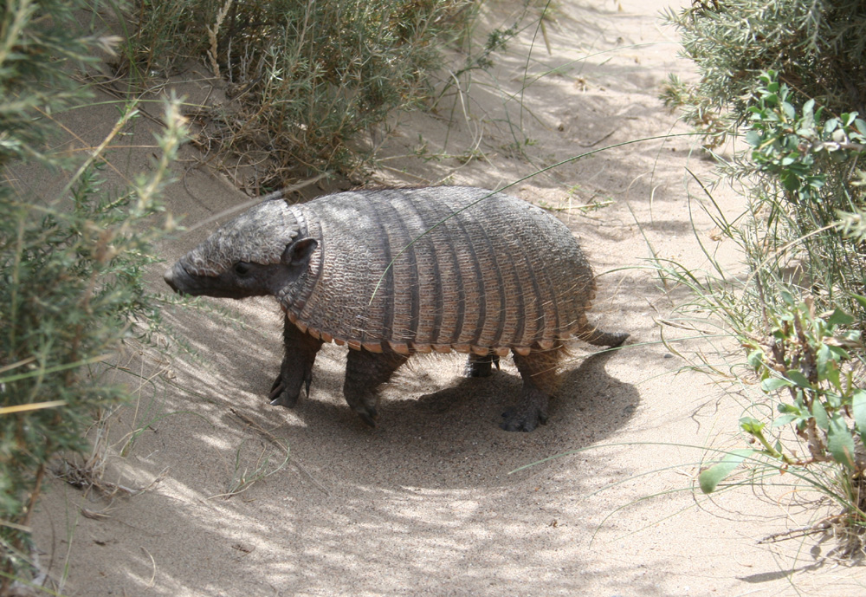
Big Hairy Armadillo
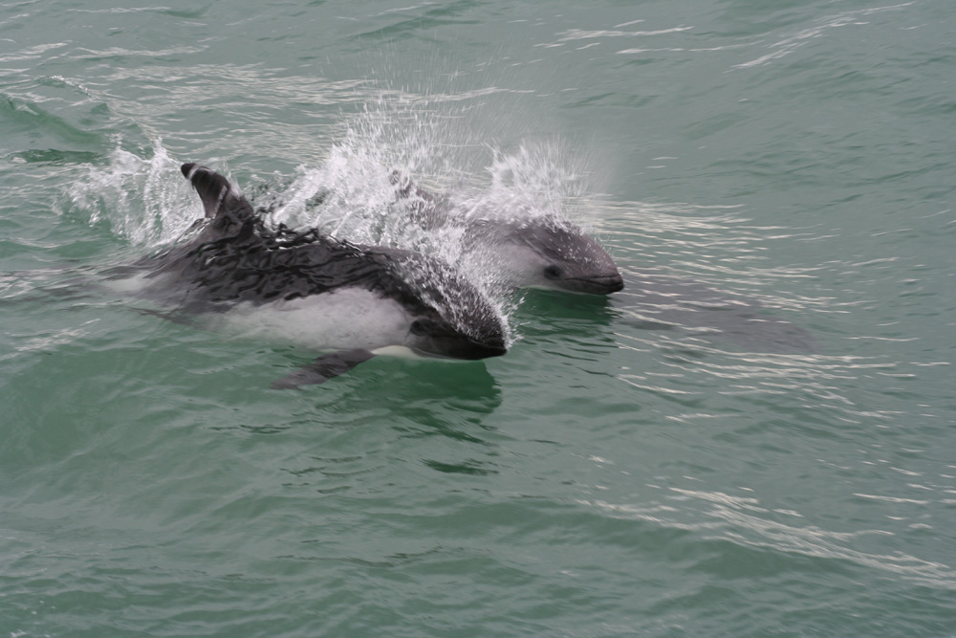
Peale's Dolphin
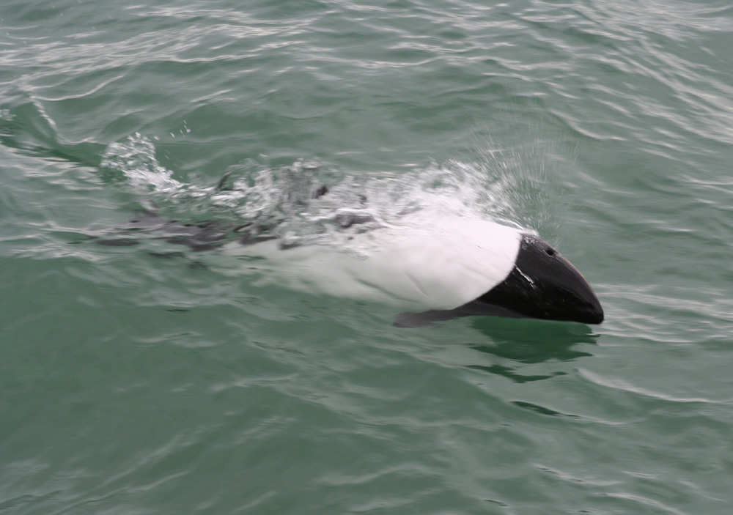
Commerson's Dolphin
Bird List

The * indicates a species whose total range is less than 50.000 km²
The species in bold are globally endangered species. The abbreviation in front of the species name indicate the threat level (nt: near-threatened, Vul: Vulnerable, End: Endangered, Crit: Critical)

nt - Greater Rhea - Rhea americana
4 around Perdices, and 4 south of San Clemente.

nt - Lesser Rhea - Pterocnemia pennata
From Valdes peninsula to the south, we saw this species daily.
The Patagonian nominate subspecies is considered by some as a distinct species from the ones found in the highland of north Chile, north Argentina, Bolivia and south Peru.

Red-winged Tinamou - Rhynchotus rufescens
1 seen and more heard during our day around Perdices, heard also around Bahia Blanca.

Brushland Tinamou - Nothoprocta cinerascens
Heard only around Bahia Blanca

Spotted Nothura - Nothura maculosa
4-5 birds when we were driving between San Clemente and Bahia Blanca, 4 more around Bahia Blanca.

Elegant crested Tinamou - Eudromia elegans
Fairly common from Viedma to Punta Tombo, with sometime more than 20 birds seen in one day.

Patagonian Tinamou - Tinamotis ingoufi
1 bird crossed the road when we were driving to Gobernador Gregores, and one excellent view on the Stroebel plateau.

nt - Gentoo Penguin - Pygoscelis papua
6 breeding pairs at the Estancia Haberton colony

nt - Magellanic Penguin - Spheniscus magellanicus
Few hundreds at the main breeding colony in Valdes peninsula, and few thousands at the Punta Tombo colony !!
A little bit more than 20 birds when we crossed the Strait of Magellan the sept. 23th.
Few hundreds at the Estancia Haberton colony

Pied-billed Grebe - Podilymbus podiceps
2 at the Costanera Sur reserve in Buenos Aires.

White-tufted Grebe - Rollandia rolland
5 at the Costanera Sur reserve, and 2 west of Bahia Blanca.

Great Grebe - Podiceps major
1 at San Clemente del Tuyu, regular sightings from Valdes peninsula to the south, 4 in the Tierra del Fuego NP close to Ushuaïa, and 2 in the Beagle channel.

Silvery Grebe - Podiceps occipitalis
2 at the Costanera Sur reserve, more than 40 on the Stroebel plateau.

* nt - Hooded Grebe - Podiceps gallardoi
Only 1 on the Stroebel plateau. The population is declining and more and more endangered !

End - Black-browed Albatross - Diomedea melanophris
We saw the first ones from Punta Arenas. Common sightings from the shore in Tierra del Fuego, and during all our boat trip (crossing the Magellan Strait, Beagle Channel or during the Navimag trip).

nt - Southern Giant Petrel - Macronectes giganteus
30-50 around the Valdes peninsula, regular sightings from the shore in south Patagonia, 15 when we crossed the Magellan Strait between Punta Arenas and Porvenir, around 10 during the boat trip in the Beagle channel.

nt - Northern Giant Petrel - Macronectes halli
1 seen from the shore at the Valdes peninsula

Southern Fulmar - Fulmarus glacialoides
8 when we crossed the Magellan Strait between Punta Arenas and Porvenir, 2 on the Beagle channel.

Vul - White-chinned Petrel - Procellaria aequinoctialis
1 on the Beagle channel

Magellanic Diving-petrel - Pelecanoides magellani
More than 30 on the Magellan Strait between Punta Arenas and Porvenir, 5 on the Beagle channel

Neotropic Cormorant - Phalacrocorax olivaceus
Common. Regular sightings from Buenos Aires to the south of Patagonia.

Rock Shag - Phalacrocorax magellanicus
More than 100 birds at the breeding colony at Punta Loma south of Valdes peninsula, 50 near the islets on the Beagle channel.

Imperial Shag - Phalacrocorax atriceps
5 from the Valdez peninsula, and regular sightings in the south of Patagonia. We found a small breeding colony in the Puerto Natales harbour, where 2 skuas tried to catch the recently borne chicks.
More than 200 on the Beagle channel

Whistling Heron - Syrigma sibilatrix
Regular sightings around Buenos Aires and San Clemente.

Cocoï Heron - Ardea cocoï
Few birds seen around Buenos Aires and San Clemente.

Great White Egret - Egretta alba
Regular sightings between Buenos Aires and Bahia Blanca, 2 birds near Puerto Madryn

Snowy Egret - Egretta thula
Regular sightings between Buenos Aires y Bahia Blanca.

Cattle Egret - Bubulcus ibis
Regular sightings between Buenos Aires and San Clemente

Striated Heron - Butorides striatus
2 birds at the Costanera Sur reserve

Rufescent Tiger-heron - Tigrisoma lineatum
1 ad. at Otamendi

Maguari Stork - Ciconia maguari
At least 15 birds around Perdices, and more than 20 around San Clemente

Black-faced Ibis - Theristicus melanopis
5 on the Valdes peninsula, and common in the south of Patagonia

White-faced Ibis - Plegadis chihi
Regular, sometime in group of 20-30 birds, between Buenos Aires and Bahia Blanca.

Roseate Spoonbill - Platalea ajaja
Few birds near Perdices and between Buenos Aires and San Clemente, also 5 birds west of Bahia Blanca.

nt - Chilean Flamingo - Phoenicopterus chilensis
More than 200 close to San Clemente, daily observations in the south of Patagonia

Southern Screamer - Chauna torquata
At least 100 between Otamendi and Perdices, few birds near San Clemente.

White-faced Whistling-duck - Dendrocygna viduata
10 between Otamendi and Perdices, 10 more between Buenos Aires and San Clemente

Black-necked Swan - Cygnus melanocorypha
More than 500 between Buenos Aires and San Clemente, more than 400 on the Stroebel plateau, and regular sightings in the south of Patagonia

Coscoroba Swan - Coscoroba coscoroba
Few hundreds between Buenos Aires and San Clemente, 20 on the Stroebel plateau, and regular sightings in the south of Patagonia.

Upland Goose - Chloephaga picta
The most common goose in the south of Patagonia. We saw the two form, one with white underside and one with barred underside, the barred form being more common farther south.

Kelp Goose - Chloephaga hybrida
1 pair south to Punta Arenas, 2 males and 4 females in te Tierra del Fuego NP, 4 on the Beagle channel

Ashy-headed Goose - Chloephaga poliocephala
Common in the south of Patagonia (first sightings between Cerro Castillo and Puerto Natales)

* Ruddy-headed Goose - Chloephaga rubidiceps
At least 30 birds south of Punta Arenas, in a small private reserve preserving a continental breeding place of this endangered species (the only safe population occurs on Falkland Islands).

Flying Steamer-duck - Tachyeres patachonicus
4 birds on the Stroebel plateau, and 2 close to Rio Grande

Flightless Steamer-duck - Tachyeres pteneres
4 in the Tierra del Fuego NP, more than 10 in the Beagle channel.

nt - White-headed Steamer-duck - Tachyeres leucocephalus
8 birds at Punta Tombo

Ringed Teal - Callonetta leucophrys
1 near Perdices

Brazilian Duck - Amazonetta brasiliensis
10 near Perdices

Chiloe Wigeon - Anas sibilatrix
Few birds around San Clemente and Bahia Blanca, common in the south of Patagonia

Speckled Teal - Anas flavirostris
Regular sightings between Buenos Aires and Bahia Blanca, 5 on the Stroebel plateau and 4 in the Tierra del Fuego NP.

nt - Spectacled Duck - Anas specularis
1 male with 5 chicks near the Perito Moreno glacier, 2 in the Tierra del Fuego NP.

Crested Duck - Anas specularioides
At least 10 on the shore at the Valdes peninsula, daily observations in Patagonia.

Yellow-billed Pintail - Anas georgica
Fairly common around Buenos Aires and common in Patagonia

White-cheeked Pintail - Anas bahamensis
10 birds found while we were driving between San Clemente and Bahia Blanca

Silver Teal - Anas versicolor
Seen daily in small quantity between Buenos Aires and Bahia Blanca, 2 on the Stroebel plateau

Cinnamon Teal - Anas cyanoptera
2 birds between San Clemente and Bahia Blanca, and 2 more west of Bahia Blanca

Red Shoveler - Anas platalea
20 between Buenos Aires and San Clemente, few around Bahia Blanca, and regular sightings in the south of Patagonia

Rosy-billed Pochard - Netta peposaca
10 at the Costanera Sur reserve, 15 between Buenos Aires and San Clemente, 1 male close to El Calafate, 1 male and 2 female between Puerto Natales and Punta Arenas

Black-headed Duck - Heteronetta atricapilla
2 birds between Buenos Aires and San Clemente

Lake Duck - Oxyura vittata
One pair between Buenos Aires and San Clemente

Turkey Vulture - Cathartes aura
Regular between Viedma and Puerto Madryn, with at least 15 birds on the Valdes peninsula.

Black Vulture - Coragyps atratus
Only seen near Bahia Blanca

nt - Andean Condor - Vultur gryphus
Few birds seen from the Perito Moreno glacier, and between Cerro Castillo and Puerto Natales. Between 2 and 5 birds seen daily around Ushuaïa.

White-tailed Kite - Elanus leucurus
2 around San Clemente

Snail Kite - Rostrhamus sociabilis
3 at Otamendi, and 3 more between Buenos Aires and San Clemente

Long-winged Harrier - Circus buffoni
Only seen between Buenos Aires and San Clemente, with about 10 birds seen just in the surroundings of San Clemente.

Cinereous Harrier - Circus cinereus
1 female near San Clemente, regular sighting in Patagonia from Gobernadore Gregores southward.

Chilean Hawk - Accipiter chilensis
1 only seen by Fabrice, as the bird crossed the road just in front of the minibus…

Harris's Hawk - Parabuteo unicinctus
1 in Otamendi, 2 near San Clemente

Black-chested Buzzard-eagle - Geranoaetus melonoleucus
1 immature bird near Gobernador Gregores, 1 close to El Calafate, 2 between Cerro Castillo and Puerto Natales, 2 in the Tierra del Fuego NP.

Roadside Hawk - Buteo magnirostris
1 near Perdices

Swainson's Buzzard - Buteo swainsoni
We found a flock of more than 100 birds, landed on an agricultural field and few trees, between Bahia Blanca and Viedma

Red-backed Hawk - Buteo polyosoma
Daily observations between the Valdes peninsula and El Calafate.

White-throated Caracara - Phalcoboenus albogularis
2 at the Garibaldi pass.

Southern Caracara - Caracara plancus
Daily sightings between Buenos Aires and Las Grutas, and between El Calafate and Punta Arenas. Also common in Tierra del Fuego.

Chimango Caracara - Milvago chimango
Very common. seen every days.

American Kestrel - Falco sparverius
1-3 birds seen almost every days

Aplomado Falcon - Falco femoralis
1 in the Stroebel plateau

Peregrine Falcon - Falco peregrinus
1 in the Valdes peninsula

Limpkin - Aramus guarauna
2 in Otamendi

Rufous-sided Crake - Laterallus melanophaius
1 seen in Otamendi

Vul - Austral Rail - Rallus antarcticus
2 birds seen near Gobernador Gregores

Giant Wood-rail - Aramides ypecaha
2 in Otamendi

Plumbeous Rail - Pardirallus sanguinolentus
Heard in Otamendi, and 2 seen west of Bahia Blanca

Moorhen - Gallinula chloropus
1 in the Costanera Sur reserve

White-winged Coot - Fulica leucoptera
Few birds seen around San Clemente and Bahia Blanca

Red-gartered Coot - Fulica armillata
Few birds seen around San Clemente, Bahia Blanca, and on the Stroebel plateau

Red-fronted Coot - Fulica rufifrons
Few birds seen in the Costanera Sur reserve, around San Clemente and Bahia Blanca.

Wattled Jacana - Jacana jacana
Only 1 in Otamendi, but 5 at the Costanera sur reserve.

Magellanic Oystercatcher - Haematopus leucopodus
We found the first pair on the Stroebel plateau. Farther south, we did regular sightings of this Oystercatcher, the only one seen inland.

Blackish Oystercatcher - Haematopus ater
4 birds south to Puerto Madryn

American Oystercatcher - Haematopus palliatus
Regular in small numbers from Buenos Aires to Comodoro Rivadavia

White-backed Stilt - Himantopus (mexicanus) melanurus
Fairly common from Buenos Aires to Bahia Blanca, with a max of 50 birds around San Clemente.

Southern Lapwing - Vanellus chilensis
Very common, from Buenos Aires to the southern part of Patagonia.

American Golden Plover - Pluvialis dominica
1 near San Clemente, at least 15 at Punta Rasa, and 4 on the Valdes peninsula.

Collared Plover - Charadrius collaris
1 near San Clemente

Two-banded Plover - Charadrius falflandicus
3 on the Valdes peninsula, 1 on road to Punta Tombo, 10+ on the Stroebel plateau and few pairs with recently born chicks around Rio Grande.

Rufous-chested Plover - Charadrius modestus
1 breeding pair found on the way to Cabo Virgines

Tawny-throated Dotterel - Oreopholus ruficollis
1 ad probably incubating on the Valdes peninsula, 2 ad with chicks near Rio Grande.

* nt - Magellanic Plover - Pluvianellus socialis
1 on the Stroebel plateau

South American Snipe - Gallinago paraguaiae
2 seen at Otamendi, 1 flushed near Gobernador Gregores and 1 excellent scope view during a lunch stop between Puerto Natales and Punta Arena.

Hudsonian Godwit - Limosa haemastica
30+ in flight near San Clemente and 20 at Punta Rasa.

Hudsonian Whimbrel - Numenius phaeopus hudsonicus
2 at Punta Rasa

Greater Yellowlegs - Tringa melanoleuca
Daily observations from Buenos Aires to Bahia Blanca

Lesser Yellowlegs - Tringa flavipes
Daily observations from Buenos Aires to Valdes peninsula

White-rumped Sandpiper - Calidris fuscicollis
Fairly common from Buenos Aires (Costanera Sur reserve) to Tierra del Fuego. So most common sandpiper in the south.

Baird's Sandpiper - Calidris bairdii
10 in the Costanera Sur reserve and few sightings in the south.

Pectoral Sandpiper - Calidris melanotos
5 at Punta Rasa

Wilson's Phalarope - Phalaropus tricolor
3 found near San Clemente and the next day more than 20 were present at Punta Rasa, and 20+ on the Stroebel plateau.

White-bellied Seedsnipe - Attagis malouinus
1 pair near the Martial glacier

Least Seedsnipe - Thinocorus rumicivorus
Fairly common in the Patagonian steppe… especially between Gobernador Gregores and Calafate !
One pair with very recently born chicks near Rio Grande.

Snowy Sheathbill - Chionis alba
52 on the shore at Comodoro Rivadavia, and 12 on the islets of the Beagle channel.

Chilean Skua - Catharacta chilensis
4 trying to catch chicks of Imperial Cormoran at Puerto Natales, 10+ in the Magellan Strait between Punta Arenas and Porvenir, 15+ on the Beagle channel, and regular sightings from the shore around Tierra del Fuego.

Brown Skua - Catharacta antarctica
5 at the Magellanic Penguin colony at Punta Tombo.

Dolphin Gull - Leucophaeus scoresbii
5 at Comodoro Rivadavia, common around Punta Arenas and Ushuaïa.

Vul - Olrogg's Gull - Larus atlanticus
30+ at Punta Rasa.

Kelp Gull - Larus dominicanus
Common along the coast.

Gray-headed Gull - Larus cirrocephalus
10 around San Clemente

Brown-hooded Gull - Larus maculipennis
Common

Sandwich Tern - Sterna sandvicensis
10 at Punta Rasa, and 2-4 at Punta Lomo south of Puerto Madryn.

Royal Tern - Sterna maxima
5 at Punta Rasa, 5-10 on the Valdes peninsula and few more birds at Punta Tombo.

South American Tern - Sterna hirundinacea
10 at Punta Rasa, regular sightings from the shore at Valdes peninsula and in the south of Patagonia. The biggest group was at least 200 birds on one small island in the Beagle channel.

Common Tern - Sterna hirundo
300+ at Punta Rasa

Snowy-crowned Tern - Sterna trudeaui
25 at Punta Rasa

Black Skimmer - Rynchops niger
30 at Punta Rasa

Rock Pigeon - Columba livia
Every cities

Picazuro Pigeon - Columba picazuro
Daily sightings from Buenos Aires to Viedma

Spot-winged Pigeon - Columba maculosa
Few birds around Viedma

Eared Dove - Zenaida auriculata
Daily observations from Buenos Aires to Cerro Castillo.

Picui Dove - Columbina picui
Few birds seen between Buenos Aires and Viedma

White-tipped Dove - Leptotila verreauxi
Few birds seen near Otamendi

Burrowing Parakeet - Cyanoliseus patagonus
50+ seen around Bahia Blanca, few birds seen on road between Las Grutas and Valdes peninsula, and at least 50 seen south to Punta Tombo.

Austral Parakeet - Enicognathus ferrugineus
Particularly unlucky with this species as we only found 1 near the Perito Moreno Glacier, and 1 in the Tierra del Fuego NP!

Guira Cuckoo - Guira guira
15+ between Otamendi and Perdices, 10+ around San Clemente, and 1 near Puerto Madryn.

American Striped Cuckoo - Tapera naevia
1 seen near Perdices, and heard at the Costanera Sur reserve.

Magellanic Horned Owl - Bubo magellanicus
1 incubating in the Tierro del Fuego NP…. in the same nest as 4 years ago !

Burrowing Owl - Athene cunicularia
10 around Bahia Blanca, and 2 near Las Grutas.

Short-eared Owl - Asio flammeus
1 at Otamendi and 1 between Puerto Natales and Punta Arenas.

Glittering-bellied Emerald - Chlorostilbon aureoventris
The only hummingbird during this part of the trip… few around Buenos Aires and 3 near San Clemente.

Green-barred Woodpecker - Colaptes melanochloros
4-5 in Otamendi, few near San Clemente.

Campo Flicker - Colaptes campestris
2-4 birds seen daily between Buenos Aires and San Clemente

Magellanic Woodpecker - Campephilus magellanicus
4 in the Tierra del Fuego NP. A wonderful view as these 2 pairs stayed in the open for at least 20 minutes !

Common Miner - Geositta cunicularia cunicularia
2 on the Valdes peninsula, and 1 on the Stroebel plateau. These bird belong to the cunicularia subspecies.

* Short-billed Miner - Geositta antarctica
1 on the Stroebel plateau, and at least 15 between Porvenir and Rio Grande

Scale-throated Earthcreeper - Upucerthia dumetaria
Only seen in small number on the Valdes peninsula, and near the Punta Lomo.

Chaco Earthcreeper - Ochetorhynchus certhioides
1 seen west of Bahia Blanca, and 1 heard at Las Grutas

Band-tailed Earthcreeper - Eremobius phoenicurus
1 seen near Punta Tombo where the species is probably common in the shrubby places, and 1 seen in Gobernador Gregores.
We also looked for this species in Chile, south of Rio Gallegos and in Tierra del Fuego, but we didn't find any…

Dark-bellied Cinclodes - Cinclodes patagonicus
1 pair at the Argentinean border control, between Rio Grande and Porvenir (near San Sebastian).

Bar-winged Cinclodes – Cinclodes fuscus
Seen at the Garibaldi pass, and near the Martial glacier.

Rufous Hornero - Furnarius rufus
Common. Seen daily between Buenos Aires and Las Grutas.

Curve-billed Reedhaunter - Limnornis curvirostris
2 at Otamendi

nt - Straight-billed Reedhaunter - Limnoctites rectirostris
1 at Otamendi

Wren-like Rushbird - Phleocryptes melanops
Seen and Heard around San Clemente, heard west of Bahia Blanca, and heard again in the marshes near Gobernador Gregores.

Thorn-tailed Rayadito - Aphrastura spinicauda
We saw the first ones in the Nothofagus forest near the Perito Moreno glacier. The species is fairly common in these kind of forest, especially in the Tierra del Fuego NP.

Plain-mantled Tit-spinetail - Leptasthenura aegithaloides
3 seen at Las Grutas, and 1 on Valdes peninsula. These bird belong to the pallida subspecies (a possible forthcoming split).

nt - Bay-capped Wren-spinetail - Spartanoica maluroides
Heard near San Clemente and west of Bahia Blanca. We only saw one, but a nice one as this bird was enough quiet to permit us to have a scope view !

Chotoy Spinetail - Schoeniophylax phryganophilus
3 near Perdices

Sooty-fronted Spinetail - Synallaxis frontalis
1 at Otamendi

Pale-breasted Spinetail - Synallaxis albescens
1 seen and 1 heard west of Bahia Blanca, and 2 more seen at Las Grutas.

Spix's Spinetail - Synallaxis spixi
2 seen near Otamendi

Sulphur-beared Spinetail - Cranioleuca sulphurifera
1 at Otamendi, 1 near San Clemente

Stripe-crowned Spinetail - Cranioleuca pyrrhophia
2-3 seen at Las Grutas

Austral Canastero - Asthenes anthoides
1 pair on Tierra del Fuego, between San Sebastian and Cullén.

Hudson's Canastero - Asthenes hudsoni
3 near San Clemente

Sharp-billed Canastero - Asthenes pyrrholeuca
1 on the Valdes peninsula

Short-billed Canastero - Asthenes baeri
2 west of Bahia Blanca and 3 at Las Grutas

Patagonian Canastero - Asthenes patagonica
1 on the Valdes peninsula, near Puerto Pyramides.

Freckle-breasted Thornbird - Phacellodomus striaticollis
1 at Otamendi and 3 near San Clemente.

Firewood-Gatherer - Anumbius annumbi
2 near Perdices

Brown Cachalote - Pseudoseisura lophotes
2 west of Bahia Blanca and 2 at Las Grutas

White-throated Cachalote - Pseudoseisura gutturalis
2 at Las Grutas

White-throated Treerunner - Pygarrhichas albogularis
3-4 birds seen in the Tierra del Fuego NP, excellent views of at least 5 birds during our trekking day west of Ushuaïa, and heard in the forest below the Martial glacier.

Scimitar-billed Woodcreeper - Drymornis bridgesii
1 near Perdices

Narrow-billed Woodcreeper - Lepidocolaptes angustirostris
1 at Otamendi

Sandy Gallito - Teledromas fuscus
1 at Las Grutas

Magellanic Tapaculo - Scytalopus magellanicus
1 came in the open near the Perito Moreno glacier, and we heard one west of Ushuaïa.

White-tipped Plantcutter - Phytotoma rutila
5 west of Bahia Blanca

White-crested Elaenia - Elaenia albiceps
3-4 at Las Grutas. Fairly common in the south of Patagonia, in all the wooded areas.

Small-billed Elaenia - Elaenia parvirostris
2 seen and more heard at Otamendi.

Suiriri Flycatcher - Suiriri suiriri
3-4 west of Bahia Blanca. These birds are sometimes called Chaco Suiriri and considered as a valid species. The SACC (South American Classification Committee) doesn't split the Chaco Suiriri.

Yellow-billed Tit-tyrant - Anairetes flavirostris
1 at Las Grutas

Tufted Tit-tyrant - Anairetes parulus
1 at Las Grutas, two observations of 1 bird on the Valdes peninsula, and 1 near Calafate.

Sooty Tyrannulet - Serpophaga nigricans
2 at Otamendi

White-crested Tyrannulet - Serpophaga subcristata
1 at Perdices, 2 near San Clemente, few west of Bahia Blanca and at Las Grutas.

Serpophaga sp griseiceps
At least 2 pairs at Las Grutas. The voice is distinctive and the best feature to separate this undescribed species from the White-crested Tyrannulet.

Warbling Doradito - Pseudocolopteryx flaviventris
2 seen near San Clemente. The Chilean and the Argentinean populations of Warbling Doradito have completely different songs and will probably be split.

Greater Wagtail-tyrant - Stigmatura budytoides
2 west of Bahia Blanca, and 1-2 at Las Grutas

Southern Scrub-flycatcher - Sublegatus modestus
2 west of Bahia Blanca

Many-colored Rush-tyrant - Tachuris rubrigastra
Seen near San Clemente

Vermilion Flycatcher - Pyrocephalus rubinus
Daily observations from Buenos Aires to Las Grutas

Austral Negrito - Lessonia rufa
Common south to Gobernador Gregores.

Spectacled Tyrant - Hymenops perspicillatus
Common between Buenos Aires and Viedma, and around Gobernador Gregores.

Hudson's Black-tyrant - Knipolegus hudsoni
At least 3 males at Las Grutas

White-winged Black-tyrant - Knipolegus aterrimus
1 pair at Las Grutas

Yellow-browed Tyrant - Satrapa icterophrys
1 near Otamendi

Black-backed Water-tyrant - Fluvicola albiventer
1 near San Clemente.

* Chocolate-vented Tyrant - Neoxolmis rufiventris
2 seen on the way to Gobernador Gregores, at least 10 on the Stroebel plateau, and few more between Gobernador Gregores and Calafate. 2 birds also have been found in the north of Tierra del Fuego.

Fire-eyed Diucon - Xolmis pyrope
5-10 birds seen near the Perito Moreno glacier, and regular sightings in the Tierra del Fuego NP.

Black-crowned Monjita - Xolmis coronata
3 at Las Grutas

White Monjita - Xolmis irupero
3 near Perdices, and 2-3 on road between Bahia Blanca and Viedma.

Rusty-backed Monjita - Xolmis rubetra
2 near Punta Norte on the Valdes peninsula.

Gray-bellied Shrike-tyrant - Agriornis microptera
1 on the Valdes peninsula.

Lesser Shrike-tyrant - Agriornis murina
5 on the Valdes peninsula.

Ochre-naped Ground-tyrant - Muscisaxicola flavinucha
2-3 birds at the Garibaldi pass, and 1 near the Martial glacier.

Dark-faced Ground-tyrant - Muscisaxicola macloviana
Fairly common in the Tierra del Fuego island, where we saw it daily.

Cattle Tyrant - Machetornis rixosa
Seen daily between Buenos Aires and San Clemente.

Great Kiskadee - Pitangus sulphuratus
Seen daily between Buenos Aires ad Viedma, 1 at Las Grutas, and 1 at Trelew.

Crowned Slaty Flycatcher - Griseotyrannus aurantioatrocristatus
2 west of Bahia Blanca.

Tropical Kingbird - Tyrannus melancholicus
Only seen around Buenos Aires (including Otamendi and Perdices) and San Clemente.

Eastern Kingbird - Tyrannus tyrannus
1 found in the Valdes peninsula. This is one of the southern record of the species in South America !

Fork-tailed Flycatcher - Tyrannus savana
Daily sightings between Buenos Aires and Las Grutas.

Brown-crested Flycatcher - Myiarchus tyrannulus
1 at Perdices

White-rumped Swallow - Tachycineta leucorrhoa
Common around Buenos Aires, Otamendi and San Clemente

Chilean Swallow - Tachycineta leucopyga
We found our first Chilean Swallow in the Valdes peninsula. Then, we saw this species daily.

Gray-breasted Martin - Progne chalybea
4 at San Clemente.

Southern Martin - Progne elegans
4-10 birds seen daily between Bahia Blanca and Puerto Madryn.

Brown-chested Martin - Phaeoprogne tapera
Seen around Buenos Aires and San Clemente.

Blue-and-white Swallow - Notiochelidon cyanoleuca
1 on the Valdes peninsula, 1 near Puerto Madryn, and 3 near Calafate.

Barn Swallow - Hirundo rustica
5 at Campo del Tuyu near San Clemente, and few around Bahia Blanca

Short-billed Pipit - Anthus furcatus
1 seen near Puerto Madryn

Yellowish Pipit - Anthus lutescens
2 at Perdices

Correndera Pipit - Anthus correndera
Few where flushed at Campo del Tuyu near San Clemente, and 1 on the Stroebel plateau. Also found between Puerto Natales and Punta Arenas during a lunch stop.

Grass Wren - Cistothorus platensis
2 near Gobernador Gregores

Southern House Wren - Troglodytes aedon
A common species seen almost every day.

Chalk-browed Mockingbird - Mimus saturninus
Common around Otamendi and San Clemente.

Patagonian Mockingbird - Mimus patagonicus
Only seen between the Valdes peninsula and Punta Tombo.

White-banded Mockingbird - Mimus triurus
Seen daily, in small numbers, between San Clemente and Valdes peninsula.

Rufous-bellied Thrush - Turdus rufiventris
Seen around Otamendi, Buenos Aires and San Clemente

Austral Thrush - Turdus falcklandii
We found the first one at Puerto Pyramides in the Valdes peninsula. Common in the south of Patagonia.

Creamy-bellied Thrush - Turdus amaurochalinus
2 at Otamendi, also seen in Buenos Aires and near San Clemente

Masked Gnatcatcher - Polioptila dumicola
5 in Otamendi, and few at the Costanera Sur reserve.

Rufous-collared Sparrow - Zonotrichia capensis
Very common. Seen everyday.

Patagonian Sierra-finch - Phrygilus patagonicus
We found the first one near the Perito Moreno glacier, then the species was fairly common farther sud, especially an the Tierra del Fuego island.

Mourning Sierra-finch - Phrygilus fructiceti
Common in the Patagonian steppe, and seen daily between the Valdes peninsula and the Calafate area.

Carbonated Sierra-finch - Phrygilus carbonarius
At least 10 at Las Grutas

* Canary-winged Finch - Melanodera melanodera
Few birds in the grassland, including one very close to our vehicle permitting excellent view, on road to Cabo Virgines.

Yellow-bridled Finch - Melanodera xanthogramma
2 pairs at the Garibaldi pass, 1 pair during our trek west of Ushuaïa, and 1 pair near the Martial glacier.

Long-tailed Reed-finch - Donacospiza albifrons
2 near San Clemente

Common Diuca-finch - Diuca diuca
As the Mourning Sierra-finch, common in the Patagonian steppe.

Cinnamon Warbling-finch - Poospiza ornata
Common at Las Grutas. An excellent spot for this species !

Black-and-rufous Warbling-finch - Poospiza nigrorufa
2 seen at Otamendi, few more at the Costanera Sur reserve, and 1 west of San Clemente.

Ringed Warbling-finch - Poospiza torquata
2 at Las Grutas

Black-capped Warbling-finch - Poospiza melanoleuca
3 at Otamendi and few at the Costanera Sur reserve.

Patagonian Yellow-finch - Sicalis lebruni
1 on the Valdes peninsula, 1 on the Stroebel plateau and 1 on road between Gobernador Gregores and Calafate.

Saffron Finch - Sicalis flaveola
Few birds seen in Bahia Blanca

Grassland Yellow-finch - Sicalis luteola
Seen daily from Buenos Aires to the Valdes peninsula.

Great Pampa-finch - Embernagra platensis
5-10 birds seen daily from Buenos Aires to Bahia Blanca. These birds belong to the nominate subspecies and will maybe be split from the olivascens ssp we saw in the north-west of Argentina.

Blue-black Grassquit - Volatinia jacarina
1 at the Costanera Sur reserve.

Rusty-collared Seedeater - Sporophila collaris
1 male at the Costanera Sur reserve.

Double-collared Seedeater - Sporophila caerulescens
1 male at Otamendi and few more at the Costanera Sur reserve.

Dark-throated Seedeater – Sporophile ruficollis
1 male near Perdices

Red-crested Cardinal - Paroaria coronata
5 in Otamendi

Golden-billed Saltator - Saltator aurantiirostris
2 near Perdices, 1 west of Bahia Blanca and 2 at Las Grutas.

Glaucous-blue Grosbeak - Cyanoloxia glaucocaerulea
1 male at Otamendi

Sayaca Tanager - Thraupis sayaca
1 at the Costanera Sur reserve

Blue-and-yellow Tanager - Thraupis bonariensis
2 at Las Grutas

Southern Masked - Geothlypis aequinoctialis
4-5 at Otamendi and 2-3 at the Costanera Sur reserve. These birds belong to the velata subspecies that will perhaps be splitted as Southern Yellowthroat.

Golden-crowned Warbler - Basileuterus culicivorus
1 at Otamendi

Solitary Cacique - Cacicus solitarius
2 at the Costanera Sur reserve.

Yellow-winged Blackbird - Agelaius thilius
Common in the marshland in Otamendi, at the Costanera Sur reserve, and around San Clemente. The species is also present is the marshes near Gobernador Gregores.

Chestnut-capped Blackbird - Agelaius ruficapillus
Seen in Otamendi, at the Costanera Sur reserve, and near San Clemente.

White-browed Blackbird - Sturnella superciliaris
At least 10 birds seen in Otamendi and Perdices.

Long-tailed Meadowlark - Sturnella loyca
A very common Meadowlark. Seen daily and sometimes in large group, from Bahia Blanca to Tierra del Fuego.

Vul - Pampas Meadowlark - Sturnella defilippi
4 birds west of Bahia Blanca. As this endangered species was displaying, it was vary easy to see the black underwing.
It was impossible to find this place without the Christobald help !

Brown-and-yellow Marshbird - Pseudoleistes virescens
10+ at Otamendi. Also seen in the marshes between Buenos Aires and San Clemente, near San Clemente, and near Bahia Blanca.

Scarlet-headed Blackbird - Amblyramphus holosericus
3 at Otamendi

Austral Blackbird - Curaeus curaeus
Some groups near the Perito Moreno glacier, and at the Garibaldi pass.

Vul - Saffron-cowled Blackbird - Xanthopsar flavus
1 very close view on a pair at Perdices !!

Bay-winged Cowbird - Molothrus badius
Common in Otamendi and Buenos Aires. We also saw this species west of Bahia Blanca.

Shiny Cowbird - Molothrus bonariensis
Seen in Otamendi, at the Costanera Sur reserve, and near Bahia Blanca.

Hooded Siskin - Carduelis magellanica
Fairly common in Otamendi, Buenos Aires, San Clemente and Bahia Blanca.

Black-chinned Siskin - Carduelis barbata
10 in El Calafate, 10 near the Perito Moreno glacier, and daily observations in Tierra del Fuego island.

House Sparrow - Passer domesticus
Almost every cities and villages.

Common Starling - Sturnus vulgaris
10 at the Costanera Sur reserve.

Mammal List

Chaetophractus villosus - Big Hairy Armadillo
At least 3 in Valdes peninsula, at the Punta Norte parking. These ones are used to look for their food in the hands of the many tourists.
1 more crossing a road in south Patagonia.

Zaedyus pichiy – Pichi
1 crossed the road in front of the minibus, south of Punta Tombo.

Pseudalopex griseus - Argentine Grey Fox
Few sightings in the south of Patagonia and Tierra del Fuego island (where introduced).

Pseudalopex gymnocercus - Pampas' or Azara's Fox
1 near San Clemente

Conepatus humboldtii – Patagonian Hog-nosed Skunk
1 only seen by Fabrice, between Puerto Natales and Punta Arenas.

Otaria byronia - South American Sea Lion
Less than 20 at the Valdes peninsula, but at least 100 at Punta Lomo. And at least 300 on the small islands on the Beagle channel.

Mirounga leonina - Southern Elephant Seal
Several hundreds on the beaches of Valdes peninsula.

Eubalaena australis - Southern Right Whale
2 seen from the shore at Punta Norte on the Valdes peninsula.

Balaenoptera borealis - Sei Whale
1 seen between Punta Arenas and Porvenir.

Cephalorhynchus commersonii – Commerson's Dolphin
A small group close to our boat, between Tierra del Fuego island and the Continent.

Lagenorhynchus australis - Peale's Dolphin
A family swimming close to our boat, between Tierra del Fuego island and the Continent.

Orcinus orca - Killer Whale
5-7 seen from the shore at Punta Norte on the Valdes peninsula.

Lama guanicoe – Guanaco
Common in many places, as Valdes peninsula, Punta Tombo and around Torres del Paine NP.

Castor canadensis – Beaver
Very common on the Tierra del Fuego where introduced. The beavers now crossed the Strait of Magellan and are spreading north in Chile.

Microcavia australis - Patagonian Cavy
Several seen at Punta Tombo.

Dolichotis patagonum - Patagonian Mara
Around 10 seen in the Valdes peninsula.

Lepus europaeus - Brown (European) Hare
Introduced from Europe, this species is very common in Patagonia!

Oryctolagus cuniculus – European Rabbit
Introduces in Tierra del Fuego island where very common in the NP west of Ushuaïa.

